Lab Exercise 20- Deploy a Docker Application using AWS ECR and ECS

1. Objective
In this lab, you will learn how to:
- Build a container image using Docker
- Store the container image in Amazon Elastic Container Registry
- Deploy the container on Amazon Elastic Container Service
- Access the running application through a public endpoint

2. Prerequisites
Before starting the lab, ensure you have:
- AWS account with appropriate permissions
- Docker installed
- AWS Command Line Interface installed and configured
- Basic understanding of containers
- Internet access

3. Lab Scenario
A development team has built a small web application using containers.
Your task as a DevOps engineer is to:
- Containerize the application using Docker
- Store the container image in Amazon ECR
- Deploy the container to Amazon ECS
- Verify the application is running successfully

4. Lab Tasks
Task 1: Create a Docker Application
Create a simple application.
Example
index.html
Hello from AWS ECS Lab

Create a Dockerfile
FROM nginx
COPY index.html /usr/share/nginx/html/index.html
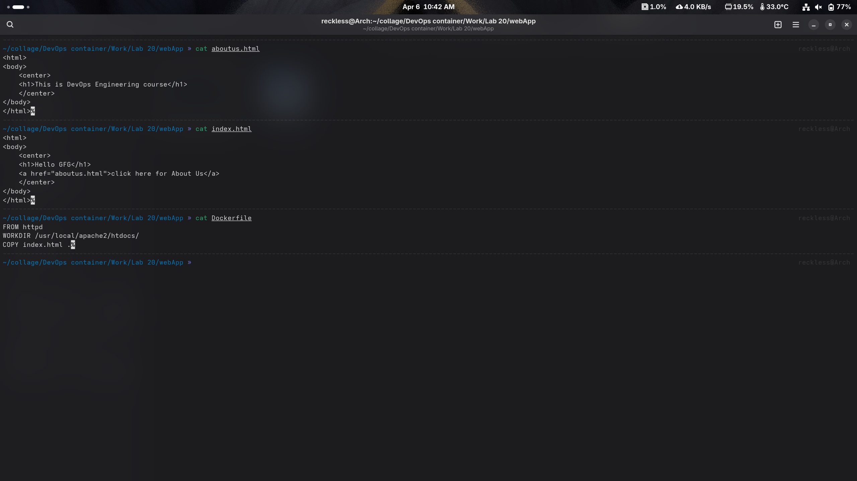
Task 2: Build the Docker Image
Build the image locally using Docker.
Docker build -t ecs-lab-app .

Verify the image.
docker images
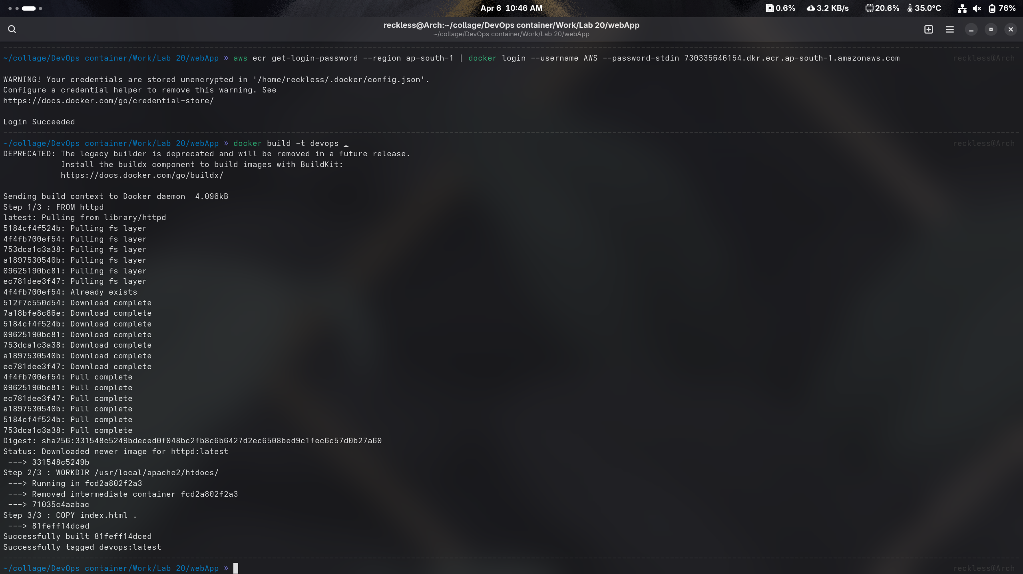

Task 3: Create an ECR Repository
Create a repository in Amazon ECR.
Steps:
- Open AWS Console
- Go to Amazon ECR
- Click Create Repository
- Repository name:
ecs-lab-repository

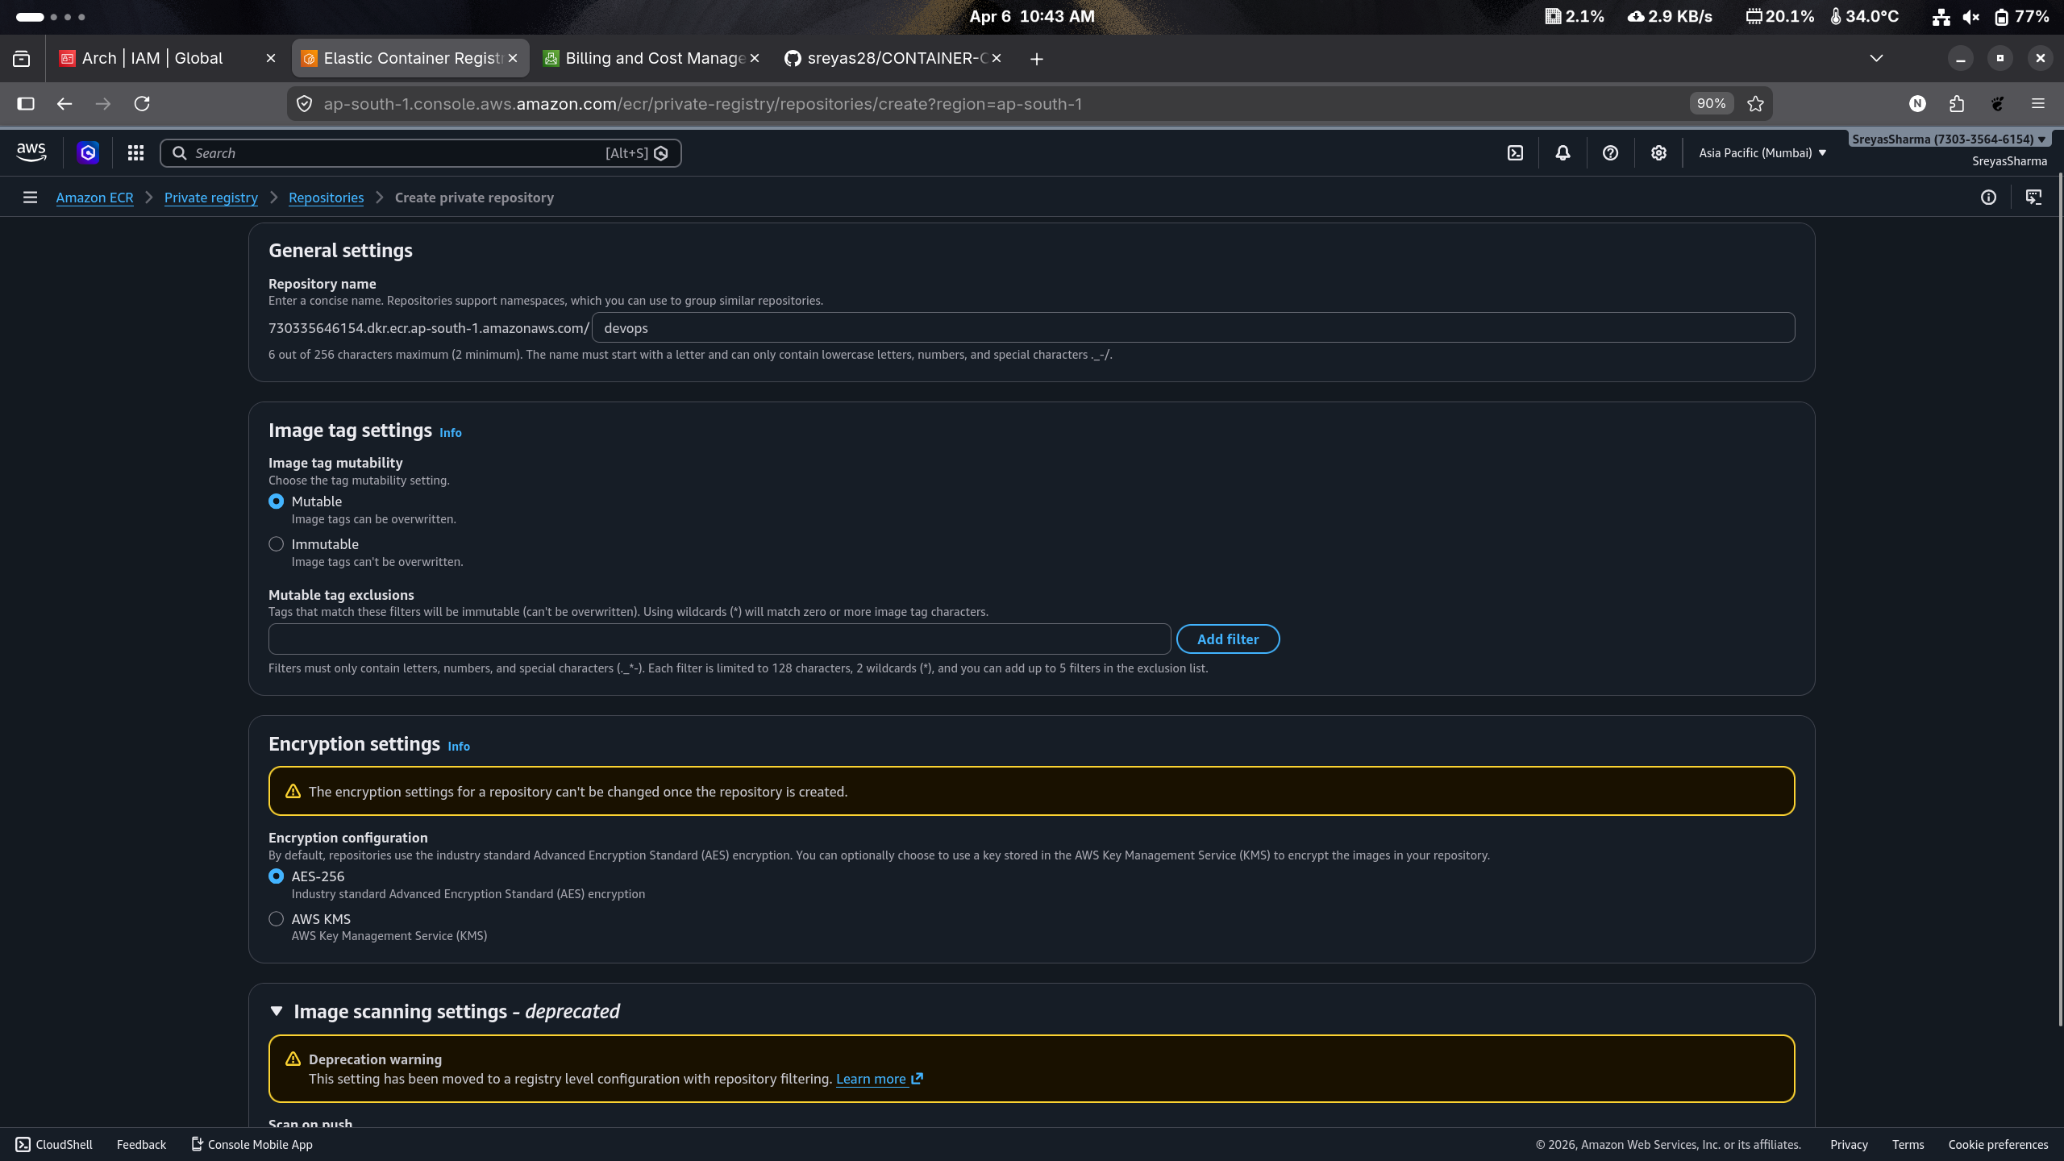
Task 4: Authenticate Docker to ECR
Login to the ECR registry using AWS CLI.
Example:
aws ecr get-login-password --region us-east-1 | docker login --username AWS --password-stdin <account-id>.dkr.ecr.us-east-1.amazonaws.com
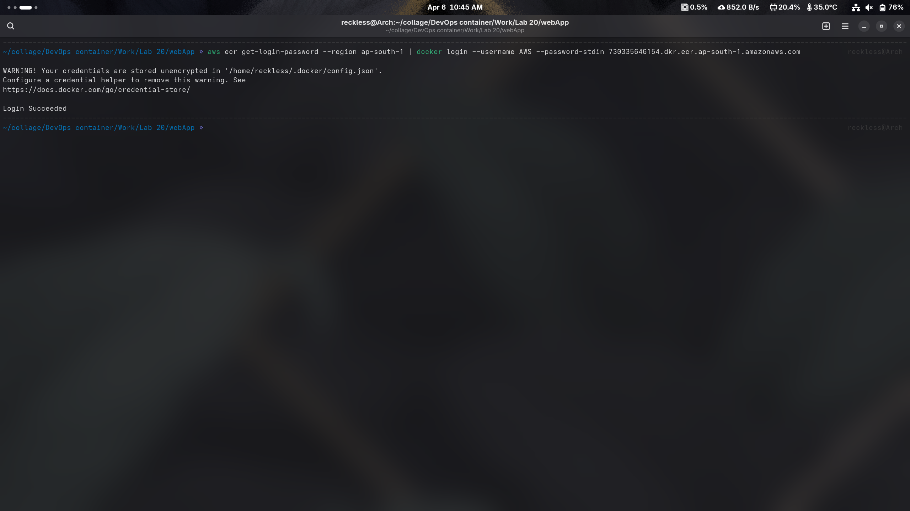

Task 5: Tag the Docker Image
Tag the image to match the ECR repository.
Example:
docker tag ecs-lab-app:latest <account-id>.dkr.ecr.us-east-1.amazonaws.com/ecs-lab-repository:latest

Task 6: Push the Image to ECR
Push the image to the repository.
docker push <account-id>.dkr.ecr.us-east-1.amazonaws.com/ecs-lab-repository:latest

Verify the image in the ECR console.

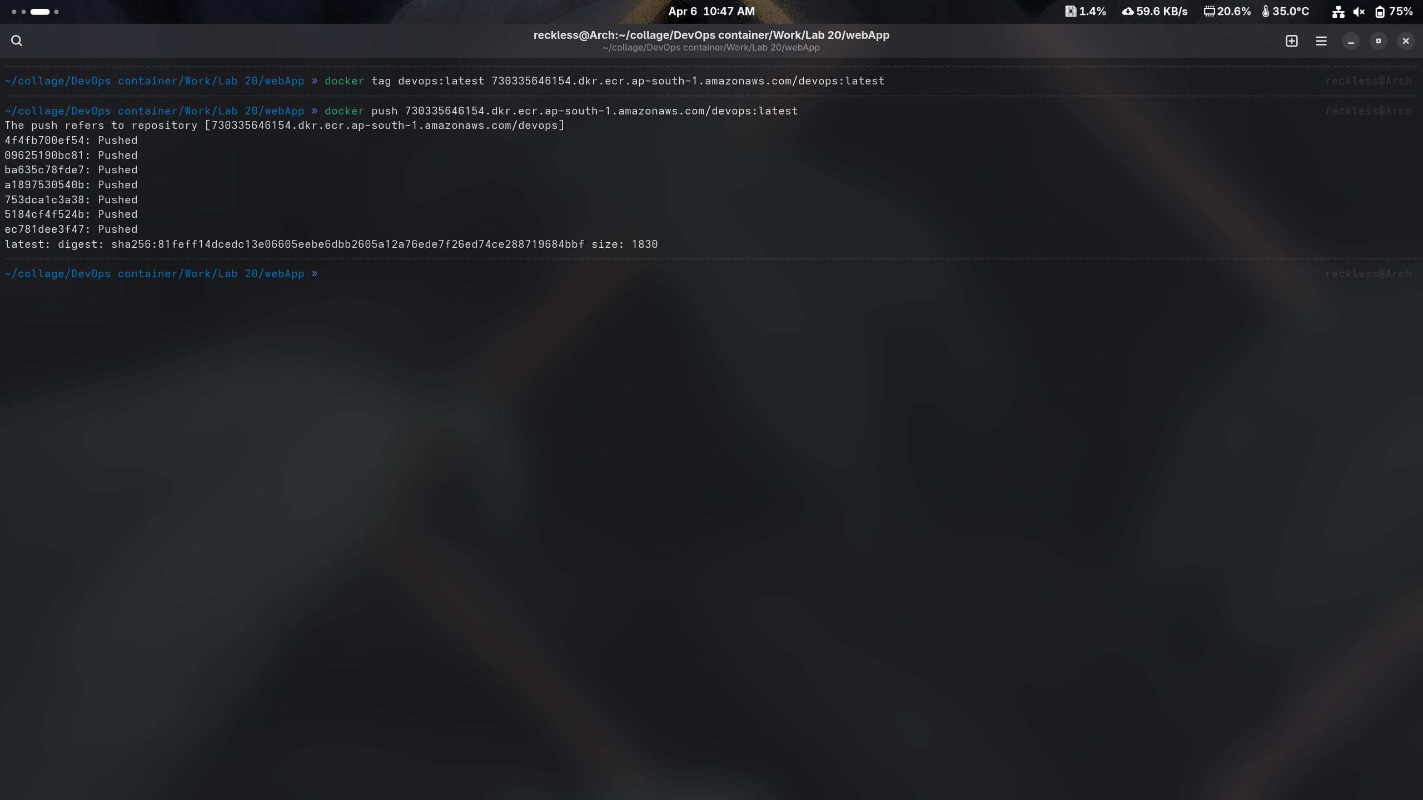
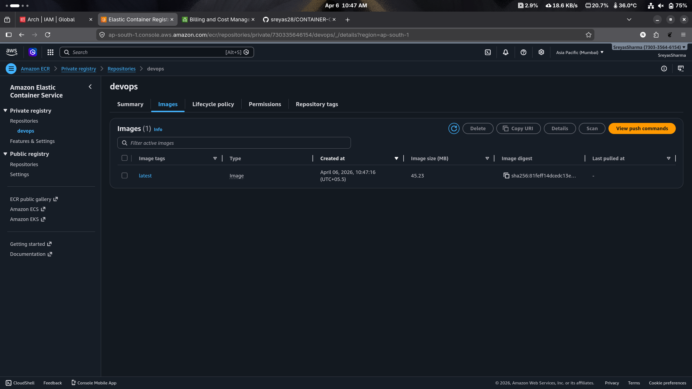
Task 7: Create ECS Cluster
Navigate to Amazon ECS.
Steps:
- Click Create Cluster
- Select Fargate
- Provide cluster name:
ecs-lab-cluster
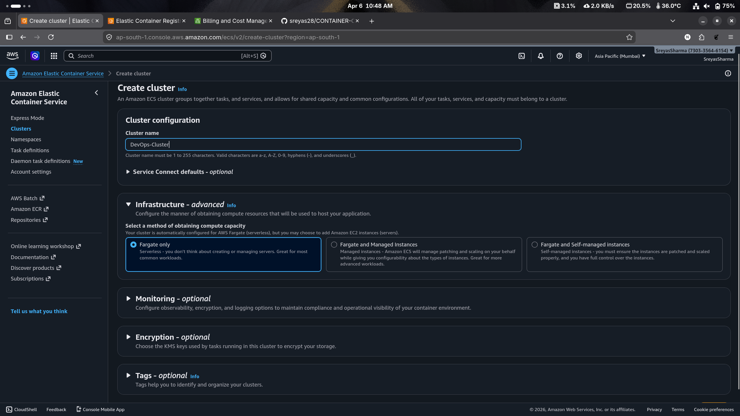

Task 8: Create Task Definition
Create a task definition.
Settings:
Container image:
<account-id>.dkr.ecr.us-east-1.amazonaws.com/ecs-lab-repository:latest
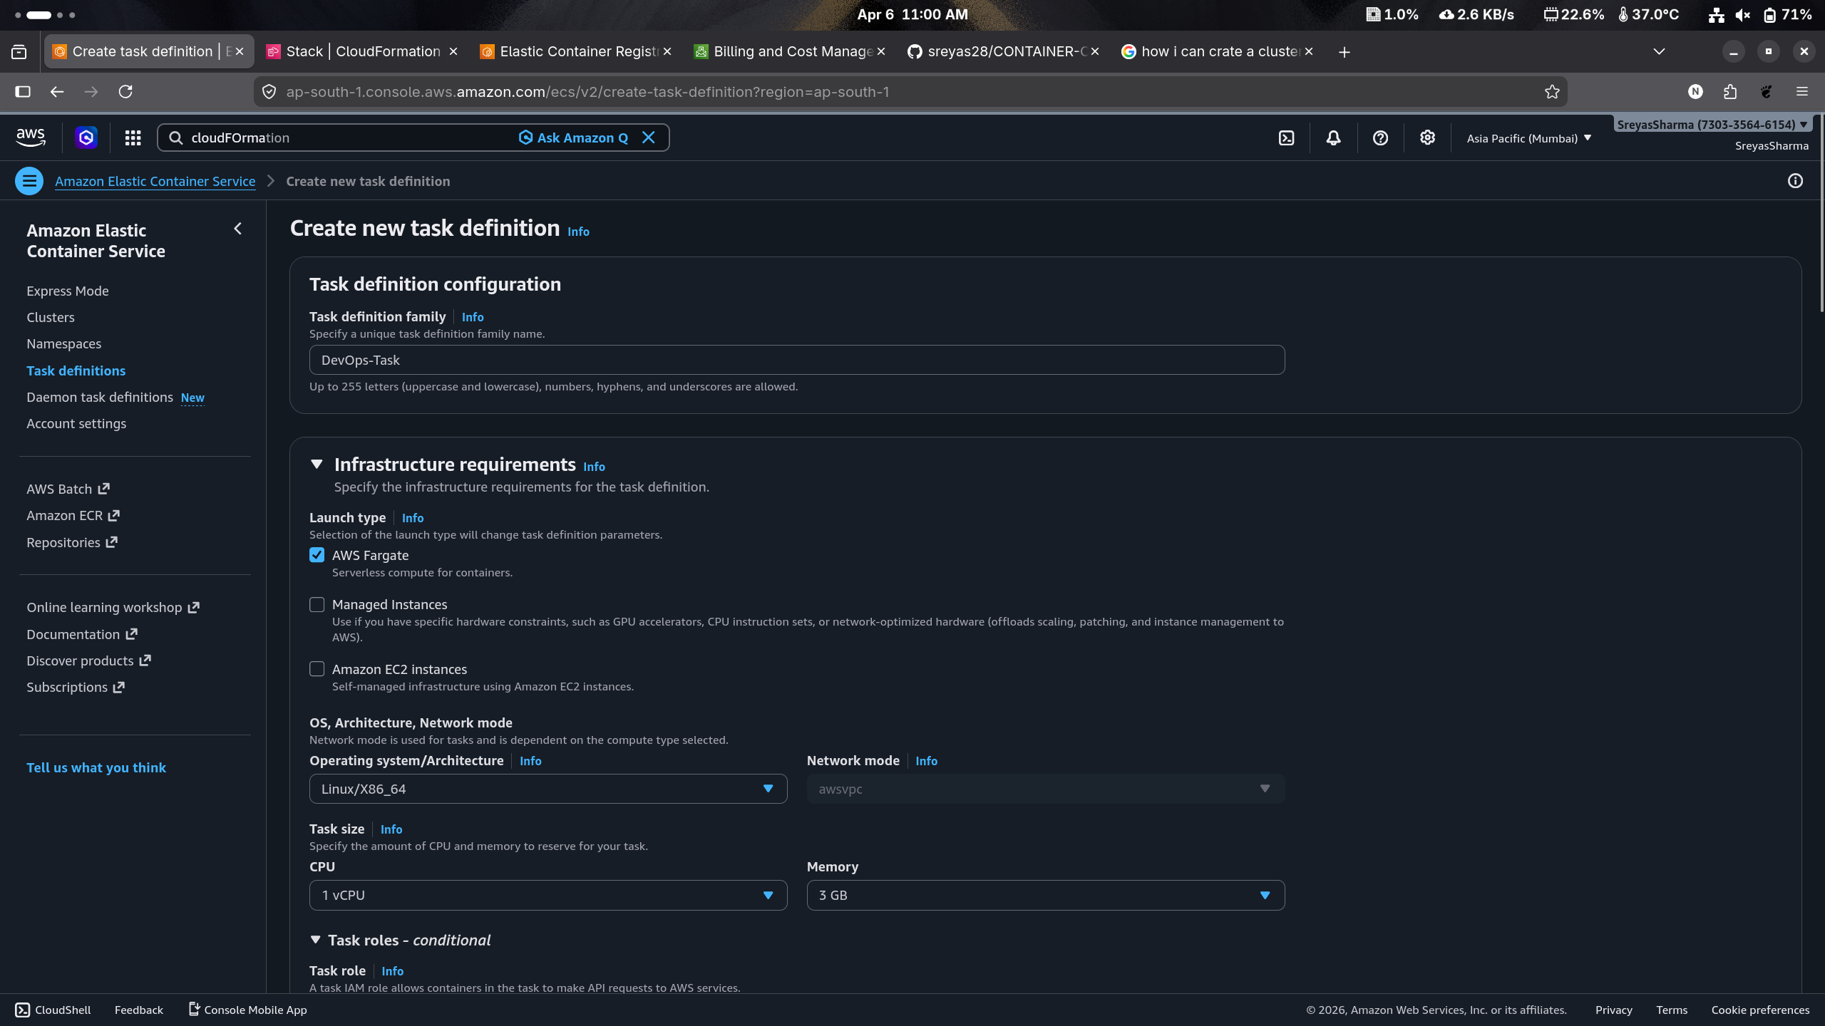
Port mapping:
80

Task 9: Run ECS Service
Deploy the container.
Steps:
- Create service
- Select Fargate
- Desired tasks:
- Enable public IP


Task 10: Verify Deployment
After deployment:
- Open ECS service
- Copy the public IP or load balancer URL
- Open in browser
Expected output:
Hello from AWS ECS Lab

5. Expected Outcome
After completing this lab:
- Docker image is stored in Amazon ECR
- Container is running on Amazon ECS
- Application is accessible through a browser
